Accessibility Camp CdA Schedule
This year, A11y Camp will have sessions in two locations on the second floor of the Edminster Student Union Building. The Lake Coeur d’Alene Room will host the main sessions and Blue Creek will provide breakout sessions.
The schedule is comprised of three tracks to ensure that every level of expertise can glean knowledge from this event:
 Passion Session – Great for ALL!
 Specialized Session – Deep dive into a specific area or topic of accessibility.
 Technical Session – Sessions that take a “how to” approach for a specific accessible outcome.

Tuesday, July 29, 2025
7:30 AM - Check-in Table Open.
8 to 9 AM – Breakfast pastries and coffee/tea in the Silver Beach Gallery on the 2nd floor of the Edminster Student Union Building.
9 AM to 3 PM – Coffee/tea in the Blue Creek/Echo Bay room on the 2nd floor of the Edminster Student Union Building.
Time | Lake Coeur d’Alene Room
9 AM to 12 PM | Document Accessibility for the Absolute Beginner (Part 1) – Dax Castro & Chad Chelius  (Session Description: T-0900)
12-1 PM | Lunch Provided by NIC
1-4 PM | Document Accessibility for the Absolute Beginner (Part 2) – Dax Castro & Chad Chelius

Wednesday, July 30, 2025
7:30AM - Check-in Table Open.
8 to 9 AM – Breakfast pastries and coffee/tea in the Silver Beach Gallery on the 2nd floor of the Edminster Student Union Building.
9 AM to 4 PM – Coffee/tea in the Blue Creek/Echo Bay room on the 2nd floor of the Edminster Student Union Building.
Time | Lake Coeur d’Alene Room | Blue Creek  Room
8:30 to 8:55 AM | Welcome to A11y Camp CdA, Opening Prayer, & Housekeeping Items – Jeremy Seda  (Session Description: W-0830) | (see Lake Coeur d’Alene Room)
8:55 to 9:00 AM | [5 minute tech break] | [5 minute tech break]
9:00 to 9:45 AM | Vibe Coding AIMAC, the AI Model Accessibility Checker. An AI Benchmark for Accessibility – Joe Devon  (Session Description: W-0900-T) | (see Lake Coeur d’Alene Room)
9:45 to 10:00 AM | [15 minute break] | [15 minute break]
10:00 to 10:45 AM |  Artificial Intelligence and Assistive Technology – Myles Pilling  (Session Description: W-1000-S) | Accessible PDFs from Microsoft Word – Chad Chelius  (Session Description: W-1000-T)
10:45 AM to 11:00 AM | [15 minute break] | [15 minute break]
11:00 to 11:45 AM | YuJa Panorama Overview – Michael Cosgrave  (Session Description: W-1100-T) | (see Lake Coeur d’Alene Room)
11:45-1:00 PM | Lunch Provided by NIC | (see Lake Coeur d’Alene Room)
1:00-1:45 PM | Digital Accessibility Long Overdue: Countdown to Compliance – Angelina Smith  (Session Description: W-1300-S) | (see Lake Coeur d’Alene Room)
1:45-2:00 PM | [15 minute break] | [15 minute break]
2:00-2:45 PM | AI as an Ally: Empowering Disability Services and Their Students – Erin C. Lucas (Session Description: W-1400-S) | Round Table Discussion: Strategy & Tactics to Prepare for Title II Update to the ADA– Moderated by Amy Taylor  (Session Description: W-1400-S2)
2:45-3:00 PM | [15 minute break] | [15 minute break]
3:00-3:45 PM | Accessibility Workflows for Success – Dax Castro & Chad Chelius (Session Description: W-1500-T) | Idaho Commission for the Blind and Visually Impaired – Jackie Stallings  (Session Description: W-1500-S)
3:45-4:00 PM | [15 minute break] | [15 minute break]
4:00-5:00 PM | Standup Comedy Show –  D.J. Demers  (Session Description: W-1600-P)  Add to Outlook or Google | (see Lake Coeur d’Alene Room)
5:00-5:10PM | Day 1 Closing Remarks – Jeremy Seda | (see Lake Coeur d’Alene Room)
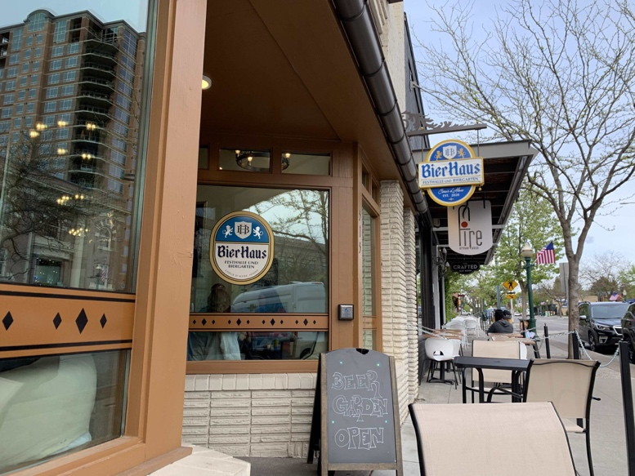
6:00PM ISU After Hours Networking Event—Dinner & “No Host” bar:
Wrist-band (distributed during closing remarks) or conference badge required.
Bier Haus (https://www.bierhauscda.com/)
515 E Sherman Ave
Coeur d'Alene, ID 83814
Menu
(bierhauscda.com/menu/)
Phone: 208-966-4301
Email: prost@bierhauscda.com

Thursday, July 31, 2025
8 to 9AM – Breakfast pastries and coffee/tea in the Silver Beach Gallery on the 2nd floor of the Edminster Student Union Building.
9 AM to 4 PM – Coffee/tea in the Blue Creek/Echo Bay room on the 2nd floor of the Edminster Student Union Building.
Time | Lake Coeur d’Alene Room | Blue Creek  Room
9:00 to 9:45 AM | Math Content: Accessibility Tools & Alternative Formats – Natalie Davison  (Session Description: TH-0900-T) | Artificial Intelligence - Friend or Foe – Myles Pilling  (Session Description: TH-0900-S)
9:45 to 10:00 AM | [15 minute break] | [15 minute break]
10:00 to 10:45 AM | Building Empathy with Dark Patterns – Chris Gaulin  (Session Description: TH-1000-P) | Diving Deeper into YuJa Panorama – Michael Cosgrave  (Session Description: TH-1000-T)
10:45 to 11:00 AM | [15 minute break] | [15 minute break]
11:00 to 11:45 AM | Evolution of the Low-Vision Classroom: Improving Access & Inclusion – Jeff Gardner  (Session Description: TH-1100-S) | Beyond Automation: The Basics and Benefits of Manual Accessibility Testing – Angelina Smith  (Session Description: TH-1100-T)
11:45 AM to 1:00 PM | Lunch Provided by NIC | (see Lake Coeur d’Alene Room)
1:00 to 1:45 PM | Digitalization, AI & Inclusion in Higher Education: EDF’s Perspective – Dr. Humberto Insolera  (Session Description TH-1300-S) | Creating Accessible PPT Documents– Dax Castro  (Session Description: TH-1300-T)
1:45 to 2:00 PM | [15 minute break] | [15 minute break]
2:00 to 2:45 PM | Inaccessible Accessibility – Christa Peters  (Session Description: TH-1400-S) | Accessibility using Venngage – Chad Chelius  (Session Description: TH-1400-T)
2:45 to 3:00 PM | [15 minute break] | [15 minute break]
3:00 to 3:45 PM | KEYNOTE: Beyond Compliance: Crafting Audio Description That Audiences Feel – Roy Samuelson  (Session Description: TH-1500-S) | (see Lake Coeur d’Alene Room)
3:45 to 4:00 PM | [15 minute break] | [15 minute break]
4:00 to 4:45 PM | Accessibility Salsa – Jeff Gardner, Karina Mason-Rorris, & Jeremy Seda  (Session Description: TH-1600-P) | (see Lake Coeur d’Alene Room)
4:45 to 5:00 PM | Day 2 Closing Remarks – Jeremy Seda | (see Lake Coeur d’Alene Room)
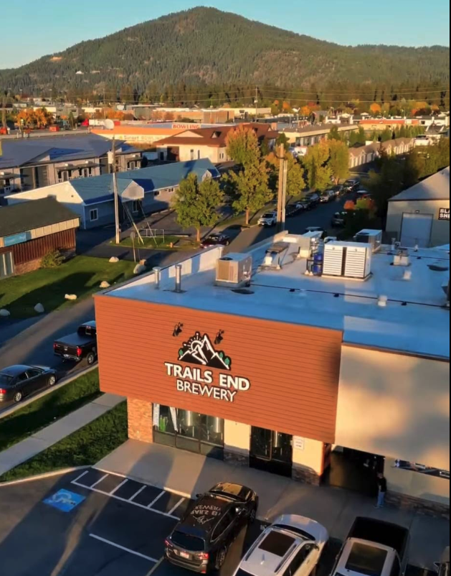
6:00 PM Irie-AT After Hours Networking Event—Dinner & “No Host” bar:
Wrist-band (distributed during closing remarks) or conference badge required.
Trails End Brewery & Brick-oven Pizza
(URL: www.trailsendbrewery.com)
356 W Bosanko Ave
Coeur d'Alene, ID 83815
Menu
(URL: www.trailsendbrewery.com/food-menu)
Phone: 208-292-4013
Email: info@TrailsEndBrewPub.com

